# Practical Expression

**Example of making reservation in hotel :**

Receptionist : Good morning. Palace Hotel. This is George. How may I help you?

Guest : Good morning this is Mike Resse. Do you have rooms available for 25th December?

Receptionist : 25th December? Ok, hold on please. I’ll check........ Yes sir we do. One room?

Guest : No we will be 4 adults and a baby. We’ll need two double rooms and one of them with an extra bed or better a cradle.

Receptionist : Sure. How many nights?

Guest : Four nights. Check in on the 25th and check out on the 29th.

Receptionist : Alright. Two double rooms with an extra cradle. Check in on the 25th and out on the 29th, is that right?

Guest : Yes, that’s correct.

Receptionist : Full board?

Guest : Half board. Breakfast and lunch. Oh and one of us is a vegetarian, so we’ll need vegetarian food for one if possible.

Receptionist : Sure, no problem but this has an extra charge of 5 € per night. Can I have your full name, please?

Guest : Sure. Mike Resse.

Receptionist : The reservation is on your name Mr. Resse.

Guest : Ok, thanks. Could I rent a car at the hotel?

Receptionist : Yes sir. Any model in particular?

Guest : I was thinking of a 5 room. Perhaps a 4 wheel drive. Do you have any offer?

Receptionist : Let me check that for you..... We have a Jeep Cherokee, the standard rate is 260€ per week but we can offer you this brandnew 4 wheel drive for 220€ a week and one gas tank for free. It’s an excellent offer sir.

Guest : Indeed. I’ll take that.

Receptionist : Perfect. Let me remind you that check-in is always after 12 pm and the rooms must be vacated before 12 pm to check out.

Guest : No problem. By the way, how much is the total including the car?

Receptionist : Our standard rate is 85 € per room and night plus any extra charge to your room. And the 4 wheel drive 200 €, unlimited mileage.

Guest : VAT included?

Receptionist : No sir, it’s not included.

Guest : All right then. Are we all set?

Receptionist : Yes sir, everything will be arrange for you arrival.

Guest : Thank you very much.

Receptionist : You are very welcome Mr. Resse. Have a nice day.

Guest : Thank you.

**Source :**

**http://www.englishclub.com/english-for-work/hotel-reservation.htm**

**Example of Check In in hotel :**

Receptionist : Welcome to Taiping Hotel. May I help you?

Customer : Yes, I’d like to check in, please.

Receptionist : Did you make a reservation?

Customer : Yes, I did. My name is Smith.

Receptionist : Yes, Mr. and Mrs. Smith. A double room for 3 nights, is that correct?

Customer : That is right. How much is the total charge?

Receptionist : $300. Could I have your signature here?

Customer : Sure.

Receptionist : Ok, here are your room keys and breakfast coupons. Have a nice day.

Customer : Thanks, you too

**Source :**

[**http://www.kierc.kh.edu.tw/db/upload/site_dynamicPageUpload/99%A4W%BE%C7%B4%C1Hotel%20dialogue%20.pdf**](http://www.kierc.kh.edu.tw/db/upload/site_dynamicPageUpload/99%A4W%BE%C7%B4%C1Hotel%20dialogue%20.pdf)

**Example of Check Out in hotel :**

Receptionist : Good afternoon, how may I help you?

Customer : Yes, I’d like to check out.

Receptionist : Can I have your room number and name, please?

Customer : My room number is 305, and my name is Smith.

Receptionist : Wait a moment, please. Here is your bill. Please check it to see if the amount is correct.

Customer : The total cost is 330. What is the extra 20 dollars for?

Receptionist : That’s for the international phone call you made in the room.

Customer : Can I pay with credit card?

Receptionist : Of course you sure. May I have your passport, please?

Customer : Here you are.

Receptionist : Here is your receipt. Thank you, have a nice day.

Customer : Thank you. Good-bye.

**Source :**

[**http://www.kierc.kh.edu.tw/db/upload/site_dynamicPageUpload/99%A4W%BE%C7%B4%C1Hotel%20dialogue%20.pdf**](http://www.kierc.kh.edu.tw/db/upload/site_dynamicPageUpload/99%A4W%BE%C7%B4%C1Hotel%20dialogue%20.pdf)

### Language Used

### Expressions of Receptionist and Guest

|  |  |
| --- | --- |
| Making Reservation | |
| Receptionist | Guest |
| Enterprise Hotels, Lise speaking. How can I help you?  What date are you looking for?  How long will you be staying?  How many adults will be in the room?  I'm afraid we are booked that weekend.  There are only a few vacancies left.  We advise that you book in advance during peak season.  Will two double beds be enough?  Do you want a smoking or non-smoking room? | I'd like to make a reservation for next week.  Is it necessary to book ahead?  Do you charge extra for two beds?  How much is it for a cot?  Do you have any cheaper rooms?  When is it considered off- season? |
| **Source : http://www.englishclub.com/english-for-work/hotel-reservation.htm** | |
| Checking In | |
| Receptionist | Guest |
| What name is the reservation under?  How long will you be staying?  Are you planning on checking out tomorrow?  I'm afraid you can't check in until after 4:00 pm.  What type of vehicle are you driving?  Do you know the license plate number of your vehicle?  Complimentary breakfast is served in the lobby between 8 and 10 am.  I'll give you two room keys.  The dining room is on the main floor at the end of the hall.  The weight room and sauna are on the top floor.  Just call the front desk if you need any extra towels or pillows. | We have a reservation under Jill McMann.  Do you have any vacancies?  Is the hotel booked, or can we get a room for tonight?  How do we get to our room from here?  Is it okay to park out front?  What time is the pool open until?  What time is breakfast served at?  Is it too early to check in?  Can we get a wake-up call?  When is check out time? |
| **Source :** [**http://www.englishclub.com/english-for-work/hotel-check-in-out.htm**](http://www.englishclub.com/english-for-work/hotel-check-in-out.htm) | |
| Checking Out | |
| Receptionist | Guest |
| Are you ready to check out?  What room were you in?  How was your stay?  Was everything satisfactory?  Will you be putting this on your card?  And how will you be paying for this?  Would you like to speak to the hotel manager on duty?  I'll just need your room keys, please.  Enjoy the rest of your holiday.  Have a safe trip home. | We're checking out of room 401.  Sorry we're a bit late checking-out.  I'm afraid we overslept/slept in.  We really enjoyed our stay.  We have a few complaints.  We'll be back next time we're in town. |
| **Source :** [**http://www.englishclub.com/english-for-work/hotel-check-in-out.htm**](http://www.englishclub.com/english-for-work/hotel-check-in-out.htm) | |

1. **Terminologies**

|  |  |
| --- | --- |
| **Average room rate** | A ratio that indicates average room rate, and to what extent rooms are being up-sold or discounted; calculated by dividing rooms revenue by number of rooms sold. Also called average daily rate or ADR. |
| **Bellboy** | A person employed by a hotel to assist guests, by carrying luggage and doing errands. |
| **Billing Clerk** | The person responsible for charging to hotel guests all vouchers representing room service, beverages, food, and merchandise purchases. |
| **Buffet** | An assortment of foods offered on a table in self-service fashion. |
| **Cafeteria** | A food service operation in which guests pass through serving lines and help themselves to food items or receive food items from service staff. |
| **Check-in** | The procedures for a guest's arrival and registration. |
| **Check-out** | (1) The procedures for a guest's departure and the settling of his or her account.  (2) A room status term indicating that the guest has settled his or her account, returned the room keys, and left the property. |
| **Day rate** | A special room rate for less than an overnight stay. |
| **Double room** | A guestroom assigned to two people. |
| **Facilities** | Core physical features of the hotel such as the type of accommodation, restaurants, bars, meeting rooms, and swimming pool. |
| **Hospitality** | The cordial and generous reception of guests. Derived from the Latin term hospes, "a guest." |
| **Hotel** | A large lodging facility, generally a hotel is full service and a multi-story building with interior entrance guest rooms. |
| **Reservations** | A guestroom that being held under an indivual or business' name at a particular hotel for a specific date or range of dates. |
| **Single room** | A single room is a room with a single bed. |
| **Twin room** | A guestroom with two twin beds. |
| **Triple room** | a room with a double bed and a single bed or three single beds. |
| **Vacant:** | A room status term indicating that the room has been cleaned and inspected, and is ready for the arriving guest. |
| **Source :**   * [**http://www.grandhotel.kg/en/hotel-glossary/**](http://www.grandhotel.kg/en/hotel-glossary/) * **http://www3.dogus.edu.tr/memek/hotel_industry_glossary.htm** | |

Exercise

Make a group, each group consist of three students then choose one topic :

* 1. Making reservation in the hotel
  2. Checking in in the hotel
  3. Checking out in the hotel

**Explanation Teaching :**

For the first time in my teaching, I come to the class and lead the pray for students. After that, they greet me and I greet them back. Before teaching the materials I give them a Hotel Picture like in power point slide.

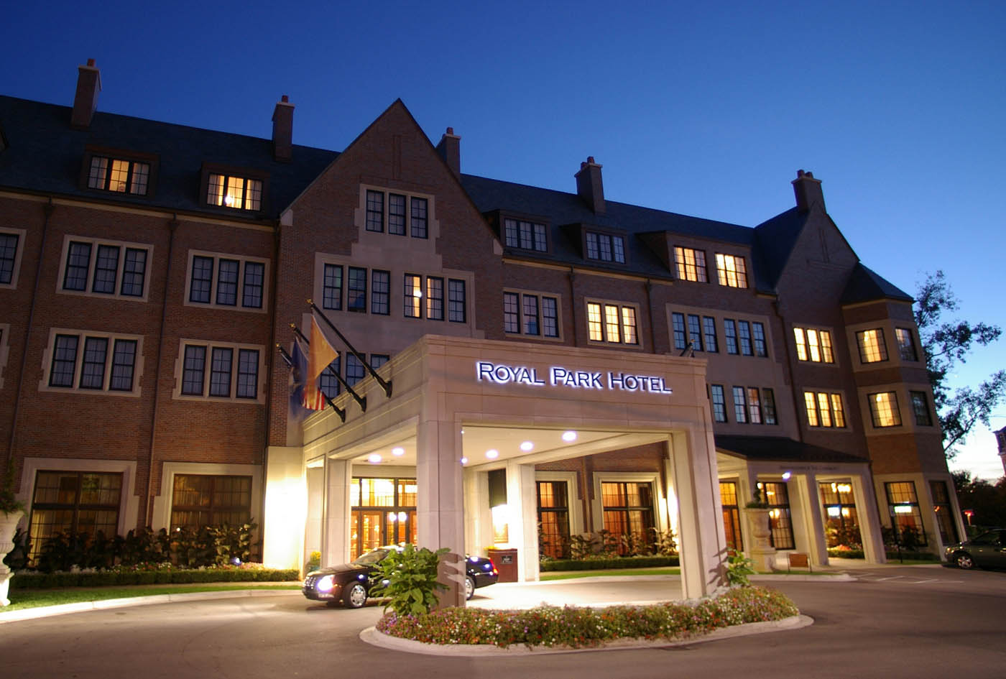

After that, I ask the students what they see in the picture and describe about the picture. After they describe the picture, I play video about the topic. After seeing the video, I ask the students about the video. It is for warming up before I getting the material. Then, I explain about the topic, the topic is English for tourism.